H.T No
Regulations:
A15


Sreenidhi Institute of Science and Technology
(An Autonomous Institution)
Code No: 5F302 Date: 14-May-2018 (AN)

B.Tech II-Year I-Semester External Examination, May - 2018 (Supplementary)
MATHEMATICAL FOUNDATIONS OF COMPUTER SCIENCE (CSE & IT)

Time: 3 Hours Max.Marks:75

Note: a) No additional answer sheets will be provided.
b) All sub-parts of a question must be answered at one place only, otherwise it will not be valued.
c) Missing data can be assumed suitably.

Part - A Max.Marks:25

Answer all QUESTIONS.

1. | Construct a truth table for 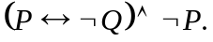 | [3M]
2. | Write about Quantifiers. | [3M]
3. | Define Covering of a set with an example. | [3M]
4. | Define semi group with an example. | [3M]
5. | Define complete bipartite graph with an example. | [3M]
6. | Define planar graph with an example. | [2M]
7. | Write about the Rules of inference. | [2M]
8. | Define Group with an example. | [2M]
9. | Define trial and circuit. | [2M]
10. | Define Boolean homomorphisan. | [2M]
Part – B Max.Marks:50
ANSWER ANY FIVE QUESTIONS. EACH QUESTION CARRIES 10 MARKS.

11. | a) | Find the PCNF of | [5M]
 | b) | Verify that the set of premise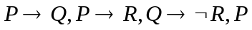 are consistent or not. | [5M]
12. | a) | Show that by using indirect method of proof. | [5M]
 | b) | Solve the Recurrence relation a_{n+1}- 2a_{n}, = 5, n≥0, a₀ =1 | [5M]
13. | a) | If A = {1, 2, 3, 4, 6, 8} and R{(a.b) / a,b Є A and a divides b} then verify the  relation R is partial ordering or not and write the relation matrix. | [5M]
 | b) | Verify the following Hasse Diagram is a lattice or not.  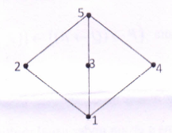 | [5M]
14. | a) | Verify that R₋₁ of real number other than -1 is a group or not with respect to the  operation defined by a * b = a + b + ab. | [5M]
 | b) | State and prove Lagrange's theorem. | [5M]
15. | a) | Verify that the following graphs are isomorphic or not  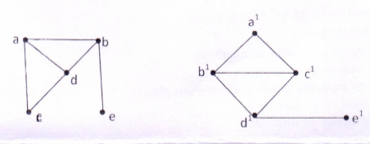 | [5M]
 | b) | Find the spanning tree for the following graph by using DFS.  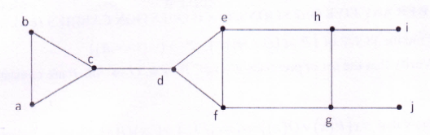 | [5M]
16. | a) | Draw the graphs for the following  (i) Neither Eulinan or Hamiltonian  (ii) Eulerian but not Hailtonian | [5M]
 | b) | Out of30 students in a hostel, 15 study Mathematics, 8 study Electronics and 6  study C programming. It is known that 3 students study all these subjects. Show that 7 or more students study none of these subjects. | [5M]
17. | a) | Verify the statement formula is a Tautology or not. | [5M]
 | b) | Write the Boolean expression 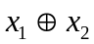in an equivalent sum of products canonical  form in three variables x₁ , x₂ and x₃. | [5M]
18. | a) | Prove that the forth roots of units forms a group under usual multiplication. | [6M]
 | b) | Find the chromatic number of the following graphs.  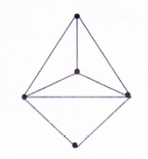 | [4M]

-- 00 -- 00 –

